**Appendix 1**.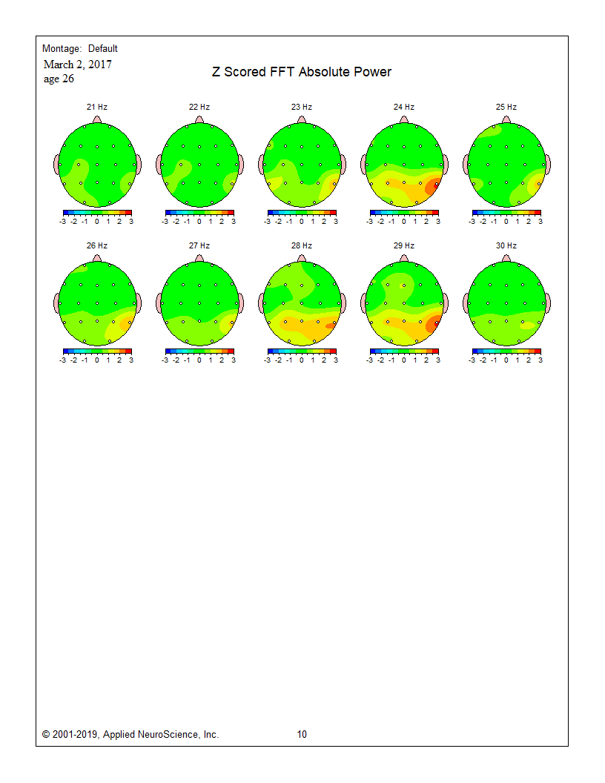

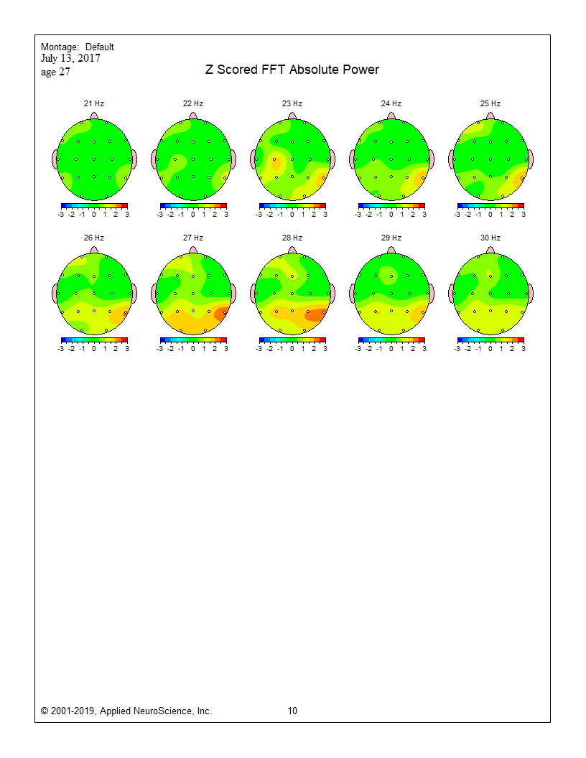

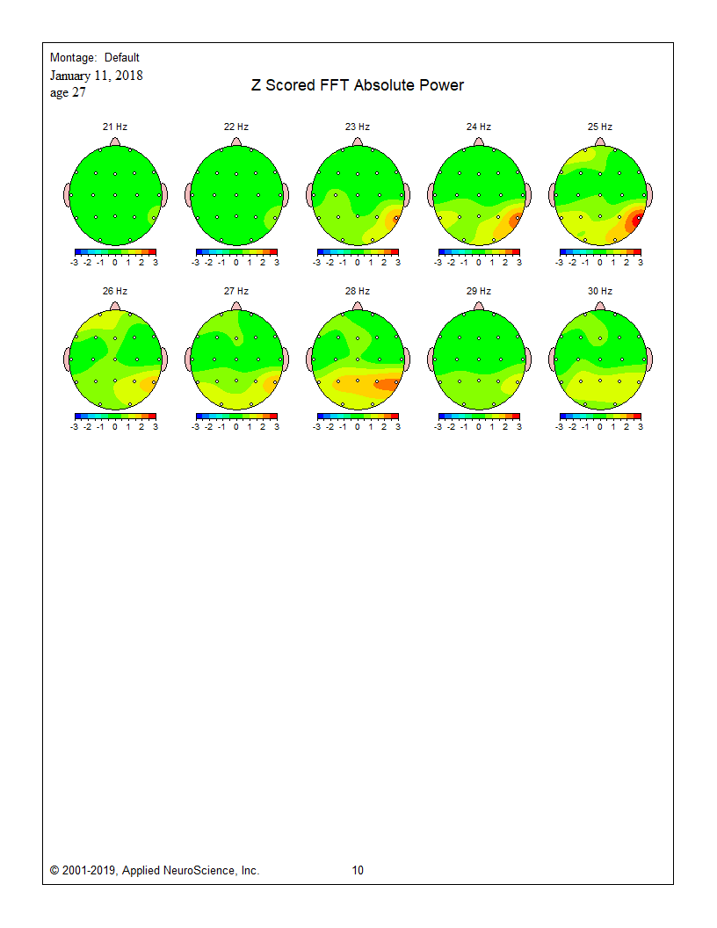

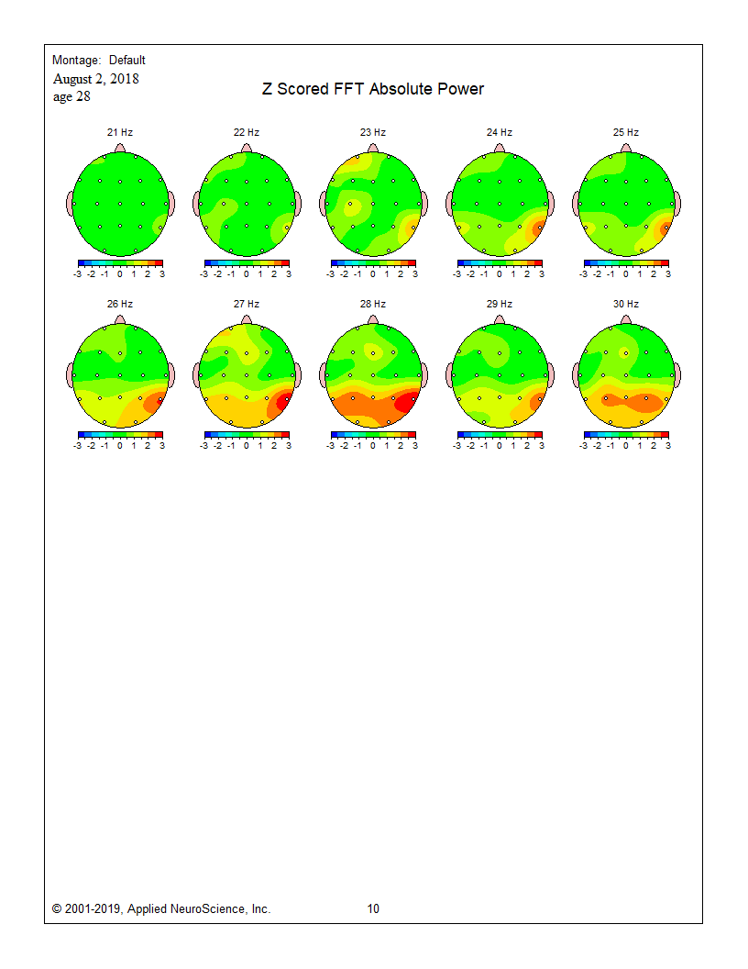

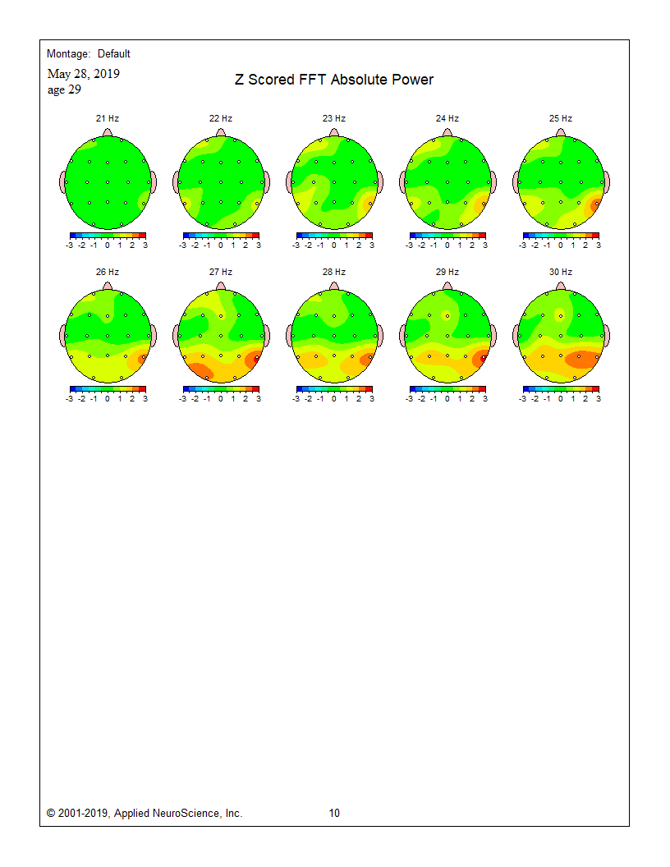

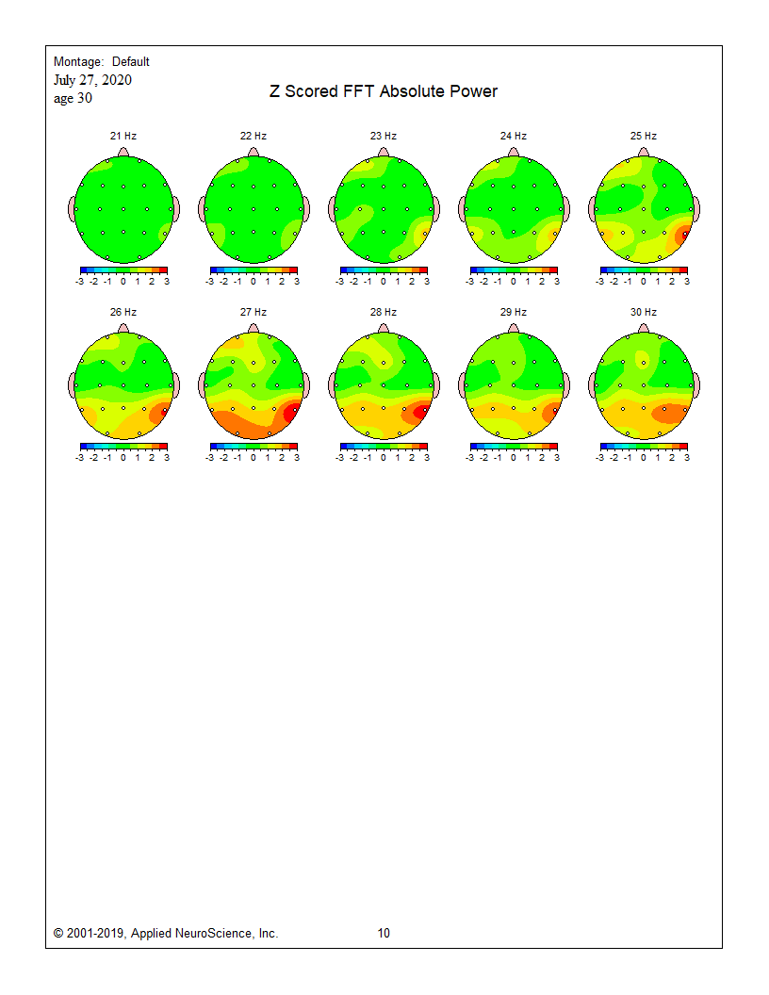

**Appendix 2**. Follow-up Interview Summary

**Follow-Up Interview, March 20, 2025**

On March 20, 2025, the subject participated in a follow-up interview, which was focused on her biological, psychological, and social functioning since the last assessment. More specifically, the follow-up interview was conducted to gather updated self-report data on her health status, physical activity, hormonal profile, psychosocial well-being, as well as general cognitive and occupational functioning.

**1. Recent Head Injuries**

The subject reported two possible concussive events since the last interview. In August 2024, she experienced a whiplash-type injury while playing in the waves at the Pinery Conservation Area. The following day, she reported experiencing post-concussion symptoms, including headache and nausea, which led her to believe the incident resulted in a concussion. She did not seek care from her physician, but instead, pursued treatment from a chiropractor and physiotherapist.

In October 2024, she became ill which resulted in elevated blood pressure, she lost consciousness, and sustained a head impact during the resulting fall. She consulted her physician, provided a medical history, but no formal concussion assessment was conducted. She initially reported improvement; however, in the two weeks preceding this follow-up interview, she noted experiencing a resurgence of concussion-type symptoms. She attributed this exacerbation potentially to increased life stressors (e.g., selling her home, returning to work, increased driving), and speculated a minor head bump may have occurred.

Additionally, the subject acknowledged the possibility of other minor head impacts that went unrecognized but suggested that the bioidentical hormones she had previously taken, and was taking at the time of these additional minor impacts to the head, may have conferred some neuroprotective effects.

**2. Physical Activity**

Subject reported that she has remained physically active. Her current regimen includes walking, stationary biking, hiking, and yoga, typically two to three times per week, with sessions lasting 30 to 45 minutes. Prior to her 2023 pregnancy, her activity level was reported to be higher and included workout classes, yoga, Pilates, and core exercises. Physical activity has continued to play an important role in her life despite recent challenges and stressors.

**3. Hormonal Status**

There has been no hormone testing since prior to giving birth to her child (2023). After giving birth, she did not menstruate for approximately one year while breastfeeding. When her menstrual cycle resumed, she reports that her milk production decreased somewhat.

The subject disclosed a prior miscarriage and reported that in her 2023 pregnancy, she received progesterone supplementation during the first 10–12 weeks of pregnancy as a precaution, given her history of amenorrhea. Hormone testing at that time revealed normal day 1 and day 21 levels, and her thyroid function was being managed medically. She discontinued bioidentical hormones in 2023 but remained on progesterone until conception in May 2023. She reported that she did not require hormonal therapy during pregnancy.

**4. Psychosocial Well-Being**

Overall, the subject described her mental health as stable and positive. She acknowledged that both the concussions and parenting a young child have made it more difficult to engage socially, but she reported feeling happy on a daily basis, with strong support from her husband, child, and social network.

The subject expressed anxiety about returning to work, particularly regarding the potential neurocognitive demands; However, she noted that over the past six years she has managed well occupationally, despite prior concussions. After the 2018 concussion, she reported she was able to meet workplace expectations, although her personal life had become more limited.

Currently, the subject is completing her maternity leave and transitioning back to work on a part-time basis (from a previous 40-hour work week) to her role as a Medical Laboratory Technologist in Genetics. She reported experiencing headaches and nausea when she overexerts herself but had previously achieved a satisfactory work-life balance prior to going on leave.

**5. Activities of Daily Living, Neurocognitive, and Occupational Functioning**

The subject reported that tasks requiring higher executive function now cause increased fatigue. Managing daily responsibilities, particularly with a new baby, has become significantly more challenging. Until her August 2024 whiplash injury, she felt she was functioning well. The subject also reported completing her Master’s degree while working full-time, suggesting a high baseline level of functioning.

With respect to nutrition, the subject’s diet remains a focal point of self-care. She follows a vegetarian diet with occasional eggs and fish, and prioritizes high-quality foods. She also takes a range of supplements, including curcumin, lecithin, omega-3 fatty acids, creatine, MCT oil, iron, and magnesium, which she reports may be somewhat beneficial.

The subject maintains a consistent sleep routine, going to bed between 9:30–10:00 PM, noting that she wakes during the night as needed for her child. She reported that her sleep quality worsens around menstruation, for which ibuprofen provides some relief. To support screen tolerance, she reports the use of “Neuro lenses,” which she advised helps reduce discomfort from digital devices.

In summary, the follow-up interview suggests that the participant, who has a history of concussions and hormonal imbalances, is currently experiencing a resurgence of post-concussion symptoms, likely triggered by recent head impacts and compounded by psychosocial stressors such as returning to work and caring for a young child. Her cognitive functioning, particularly tasks requiring executive function, has declined since an August 2024 whiplash injury, which is suspected to have resulted in concussion, noting fatigue, headaches, and nausea when overexerted. Hormonal fluctuations, including the discontinuation of bioidentical hormones, a miscarriage, and the postpartum period, may also be contributing to her symptoms, with the participant speculating that previous hormone therapy may have had neuroprotective effects. Despite these challenges, the subject maintains a healthy lifestyle through regular physical activity, a nutrient-rich diet, and supplementation, though the quantitative effectiveness of these interventions remains uncertain. Her strong social support system and overall positive mental health are protective factors, though anxiety about her occupational performance is mounting as she approaches her return to work. Moreover, she completed her **Master’s degree while working full-time**, suggesting a high baseline level of functioning despite the ongoing challenges she experiences. Taken together, her experience underscores the complex interrelationship between concussion history, hormonal changes, and psychosocial stress, suggesting a need for integrative approaches in managing long-term recovery and cognitive health.

**Appendix 3**. Spider method

